|  |
| --- |
| Abbott Laboratories |
| Sample Dispense Liquid Level Sense Based Proactive Operational Monitoring (POM) Algorithms for Faulty Cuvette Status |
| ARCHITECT Clinical Chemistry Analyzer |
|  |
| **Systems Engineering**  **ARCHITECT Clinical Chemistry Instrument TPD** |
| **Version 1.0** |
| **6/23/2016** |

|  |
| --- |
|  |

Table of Contents

1. Purpose 2

2. Introduction 2

2.1. Scope 2

2.2. Alert Notification Profile 2

2.3. Overview 3

2.4. Abbreviations 4

3. Data 4

3.1 Source 4

3.2 Physical Interpretations of Sample Dispense LLS Signals 6

4. Alerts 12

4.1 Current Thresholds Set in System Software 12

4.2 New Thresholds 13

4.3 Alert Details 14

4.4 Root Cause 14

4.5 Intervention Actions Needed 14

5. Supporting Evidence 15

5.1 Field Data Analysis 15

6. Benefits 18

7. Applicable Documents 19

7.1 Specification Documents 19

7.2 System Requirements 19

7.3 Hazard Analysis 19

# Purpose

To implement Proactive Operational Monitoring (POM) algorithms for ARCHITECT Clinical Chemistry Analyzers that detect faulty conditions for Liquid Level Sense (LLS) board and reaction cuvettes, and mal-function of Cuvette Wash Tower sub-assembly.

# 2. Introduction

## 2.1. Scope

This document describes the recommended specifications for POM Alert Notifications for the detection of faulty liquid level sense board, broken or cracked cuvettes, and cuvette wash tower mal-function on the ARCHITECT Clinical Chemistry c4000 and c16000 Analyzers.

## 2.2. Alert Notification Profile

|  |  |
| --- | --- |
| POM Alert | Sample Dispense Liquid Level Sense Voltage Signal |
| PHN Codes | PHN00042, PHN00064, PHN00065 |
| Thresholds | **PHN00042**: DisReadyAve > 15,000 for >10% of all sampling events for >10% of all cuvettes.  **PHN00064**: DisBeginAve > 20,000 for > 20% of all sampling events for > 20% of all cuvettes (A- and B-lines of c16000 instruments are treated separately).  **PHN00065**: DisBeginAve > 20,000 for > 20% of all sampling events for a total of no more than 4 (c4000) or 7 (c16000, A- and B-lines are treated separately) cuvettes.  Note: total number of sampling events for each suspected cuvette > 20. |
| Platform | ARCHITECT Clinical Chemistry Analyzer PL 127 (c16000) & 128 (c4000) installed with Pressure Monitoring Board L/N 7-900040-01, 7-900040-02, or 7-900000235-01. |
| Data Source | Instrument Result logs and Pressure Monitoring logs / Abbott Link / IDA |
| Notification | Daily Report / Instrument Serial Number(s) / Cuvette Number(s) |
| Analysis Frequency | Daily (look back one week of data FIFO daily) |
| Recommended Actions | **PHN00042**: replace sample probe pre-Amp board and/or LLS board, calibrate sample probe and inspect for vibration, inspect/align cuvette wash tower.  **PHN00064**: Inspect/replace clogged/dirty dryer tip, clogged/bent cuvette wash nozzles, and/or clogged, pinched, leaking, or disconnected tubings; align wash tower sub-assembly; calibrate sample probe.  **PHN00065**: replace individual broken/cracked cuvette(s), replace dryer tip, calibrate sample probe, and align cuvette wash tower.  ***Refer to cSystem Service & Support Manual R&R and Verification procedures*** |

## 2.3. Overview

The Liquid Level Sense (LLS) sub-system is an important design mode of control for sample/reagent detection (Figure 1). The LLS system is capacitance-based where the sample or reagent acts as a capacitor in series with the sample or reagent probe. A 32 KHz sine wave signal is applied to the probe and is also used as a reference signal input to a multiplier chip located on the LLS PCB. The 32 KHz sine wave signal from the probe is multiplied with the 32 KHz sine wave from the sine wave generator (reference signal). If the probe does not encounter liquid, there will not be a significant phase shift on the 32 KHz sine wave signal from the probe. When two sine waves that are in phase are multiplied, the output voltage is approximately zero, signifying that liquid has not been detected. If the probe encounters liquid, there will be a phase shift in the 32 KHz sine wave signal from the probe because the liquid and base plate of the instrument has some capacitance which causes a phase shift in the signal. When two sine waves that are out of phase are multiplied, an output voltage is generated signifying that liquid has been detected. In the upper section of the sample pipettor, a pre-amplifier circuit board is used to amplify and transmit the LLS signal from the probe to the LLS board. The signal, coupled back to the LLS circuit board out of phase, is taken through a circuit which converts the frequency to a DC signal that is compared to a preset threshold for the particular pipettor.

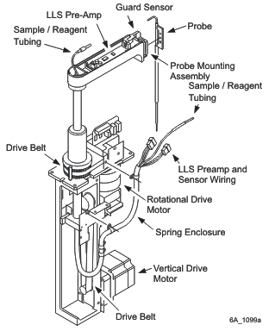 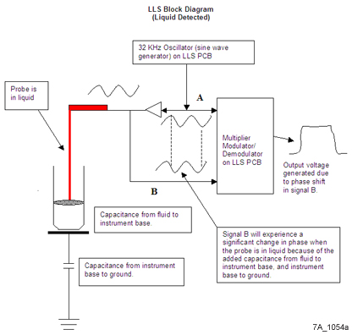

**Figure 1**. Liquid Level Sense signals detected by sample probe.

Left: Sample pipettor assembly. Right: LLS block diagram.

The algorithms described in this document embody new algorithms for ARCHITECT Clinical Chemistry Analyzers that monitor in real time the status of LLS board or reaction cuvettes and cuvette wash tower function. The algorithms utilize the principles of LLS sub-system and inspect existing LLS signals measured by the sample probe, not during sample detection for aspiration, but instead during sample dispense action from the perspective of sample probe-cuvette interactions, as indications of various faulty instrumental conditions related to cuvettes if unexpected signal patterns are detected.

## 2.4. Abbreviations

|  |  |
| --- | --- |
| LLS | Liquid Level Sense |
| AD | Analog to Digital |
| CC | Clinical Chemistry |
| IDA | Instrument Data Analytics |
| POM | Proactive Operational Monitoring |
| PM | Pressure Monitoring |
| SCC | System Control Center |

# Data

## 3.1 Source

For ARCHITECT Clinical Chemistry Analyzers that are installed with Pressure Monitoring Boards L/N 7-900040-01, 7-900040-02, or 7-900000235-01, the sample probe LLS voltage signals are recorded and processed during sample dispense action. These include all the c4000 instruments and most of the c16000 instruments. On these instruments, currently the sample dispense LLS signals in AD counts are reported for four time intervals, and they are entitled DisReadyAveV, DisBeginAveV, Dis60AveV, and DisEndAveV (see Figure 2 for Timing Chart of these events).

**DisReadyAveV**: Upon receiving the “Dispense Ready” command from the processing module, the sample probe begins downward descent into the cuvette. A total of 10 LLS AD values are collected at the beginning of the descent, and the average value of these 10 data points is calculated and designated as “DisReadyAveV”.

**DisBeginAveV**: Upon sample probe making contact with the cuvette bottom, the “Dispense Begin” command is received from the processing module. At the beginning of the delay period between contact and start of sample dispense action, a total of 10 LLS AD values are collected, and the average value of these 10 data points is calculated and designated as “DisBeginAveV.” Note that due to the delay period, sample dispense has not actually started during the data collection for DisBeginAveV.

**Dis60AveV**: During sample dispense action, a total of 10 LLS AD values are collected between 61 and 70 clock cycles after the sample dispense has started, and the average of these 10 data points is calculated and designated as “Dis60AveV”.

**DisEndAveV**: Upon completion of sample dispense action, the “Dispense End” command is received from the processing module. At the beginning of the delay period after sample dispense has completed while the sample probe is still in contact with cuvette bottom, a total of 20 LLS AD values are collected, and the average value of these 20 data points is calculated and designated as “DisEndAveV”.

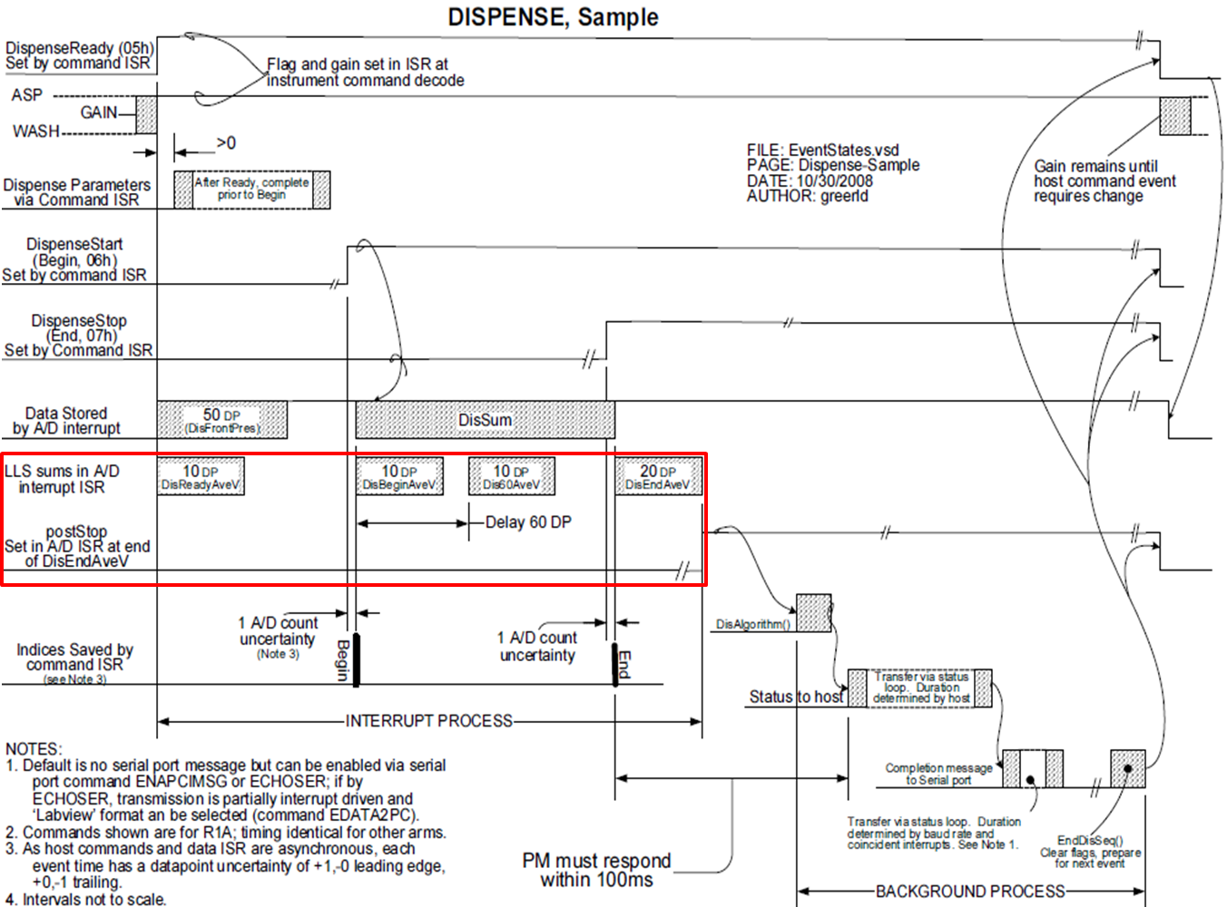

**Figure 2**. Timing diagram of sample dispense action and LLS signal processing on ARCHITECT Clinical Chemistry Analyzers.

The DisReadyAveV, DisBeginAveV, Dis60AveV, and DisEndAveV voltages in AD counts are written to LOGFIELD24, LOGFIELD25, LOGFIELD26, and LOGFIELD27, respectively, for the Sample Dispense events (RESULTCODE = 30) of the Pressure Monitoring log (see an example below).



For instruments that currently do not have the above PM boards (including all c8000 instruments and some early c16000 instruments), these sample dispense LLS signals are not processed and logged, therefore unavailable.

## 3.2 Physical Interpretations of Sample Dispense LLS Signals

Under Normal Instrument Operating Conditions

The magnitudes of these recorded LLS signals during sample dispense are reasonably predictable under normal instrument operating conditions (Figure 3 and Figure 4). Before cuvettes arrive at the sampling position, each of them has just gone through the regular cuvette wash cycle and should arrive in a clean and dry condition (Figure 3).



**Figure 3**. Interactions between sample probe and cuvette during sample dispense action under normal instrument operating condition.

When the sample probe starts to descend into the cuvette (Dispense Ready state), the LLS signals should be at a very low baseline level, with AD counts typically in the range of 0-200 (Figure 4). The LLS signal gradually increases when the sample probe is descending inside the cuvette towards the bottom because the probe is approaching the water bath which is fully electrically grounded. Once the sample probe touches the bottom of the cuvette (Dispense Begin state), the LLS signal level increases to ~6,000-10,000 AD counts, and this signal level is independent of sample dispense volume because the sample is still being held inside the sample probe. When the sample dispense action begins after a delay period, the LLS signal level again increases and continues to increase with additional sample volumes being dispensed into the cuvette leading to larger effective contact area with the cuvette bottom. The signal strength for Dis60 state is elevated relative to that of Dispense Begin state but can be variable depending on the syringe profile for the particular value of sample volume. The final signal level upon completion of sample dispense action (Dispense End state) depends largely on the specified sample dispense volume and to a lesser extent the sample characteristics (e.g., conductivity, viscosity and surface tension, etc.), which influence the coverage area and shape of the sample solution in the cuvette (via contact angle). For sample dispense volume between 1.5 uL and ~8 uL, the average signal for Dispense End state increases from ~12,000 to ~26,000 with dispense volume, with more variation for lower sample dispense volumes; above ~8 uL, the sample volume can effectively cover the entire cuvette bottom, the LLS signal is typically at the saturating level of ~26,000 with little variation and independent of the volume values (Figure 4).

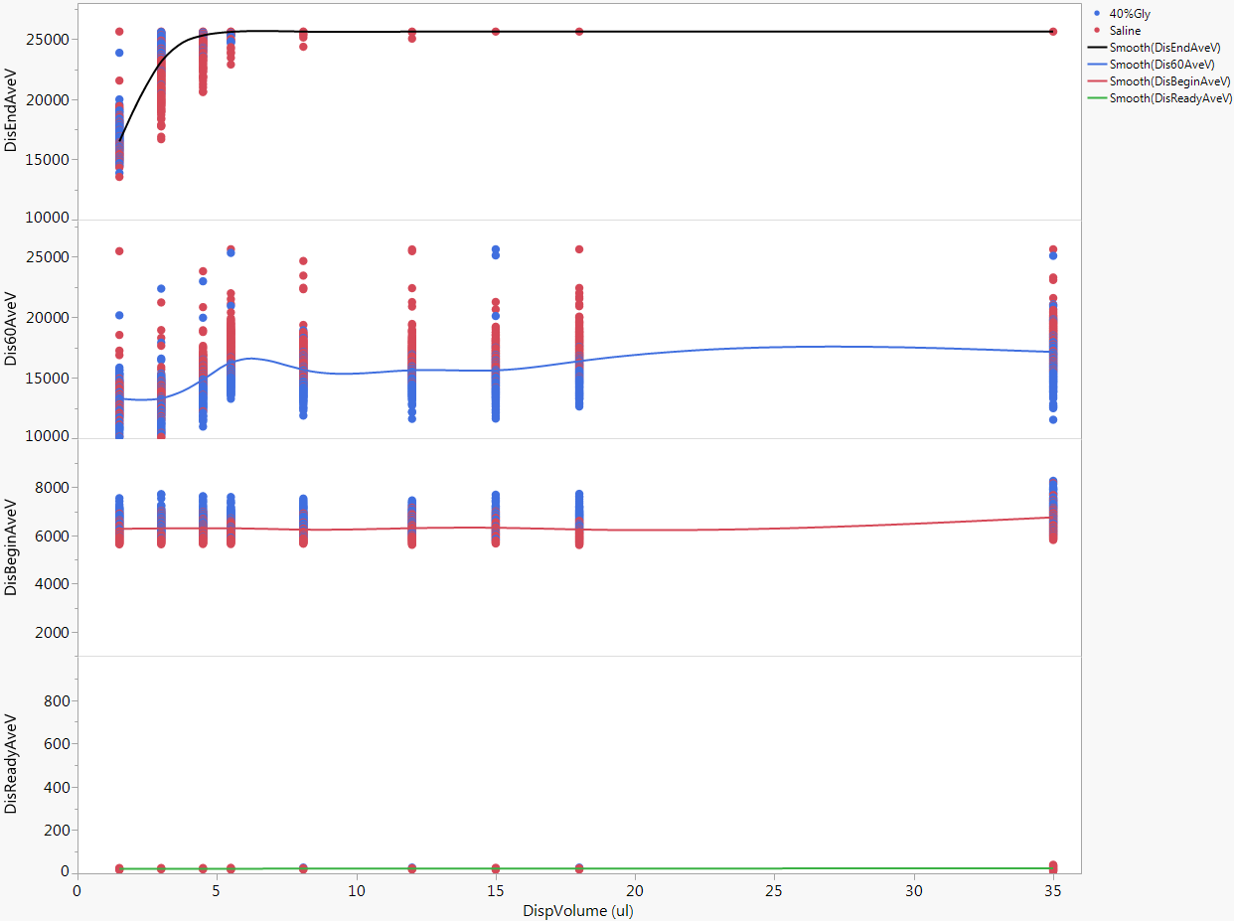

**Figure 4**. Typical sample dispense LLS signal strengths versus sample dispense volume, under normal instrument operating condition.

Under Faulty Instrument Operating Conditions

The new algorithms described in this document take advantage of the characteristic expected signal patterns of these LLS signal levels for the various states of sample probe-cuvette interactions under normal instrument operating conditions, and monitor for altered signal patterns as indications of various faulty conditions related to the states of cuvettes. Currently there are no effective Design Modes of Control onboard of ARCHITECT Clinical Chemistry Analyzers that are capable of consistently detecting these hazard sources while processing assays. The purpose of this Design Document is to outline the specifications of the monitoring algorithms for detecting the various faulty conditions to protect patient safety.

The current algorithms focus on the utilities of DisReadyAveV and DisBeginAveV signals, where either or both values can be significantly elevated if the LLS board is defective or a conductive liquid is already present inside the cuvettes prior to the start of sample dispense action. Utilities of the other signals or additional/alternative uses of DisBeginAveV signals will be described elsewhere or updated when additional new algorithms are developed.

A. Defective pre-AMP Board or LLS Board

If the pre-AMP or LLS board is defective, the DisReadyAveV signals can be significantly altered compared to the expected baseline level of 0-200. Elevated DisReadyAveV signals at almost saturating level for a small number of instruments have been observed in the field (Figure 5). For these incidents, the LLS signals start at high level for the Dispense Ready state and remain at a high level for Dispense Begin, Dispense 60, and Dispense End states (i.e. throughout the sample dispense action), regardless of the condition of the cuvette(s) and sample dispense volume. As a consequence, these elevated DisReadyAveV signals tend to mask the true values for those downstream LLS signals, rendering them un-indicative of physical states of the cuvettes.

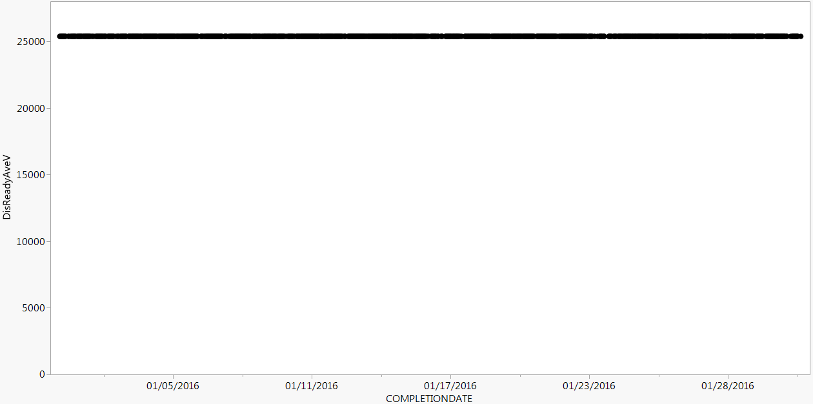

**Figure 5**. Example of elevated DisReadyAveV signals observed for c4601617.

B. Cuvette(s) Not Clean or Dry

Possible faulty cuvette conditions (Figure 6) include but are not limited to (1) individual cuvette(s) that are broken or cracked and are experiencing water bath solution seeping into the cuvette(s); or (2) a variety of mal-functions related to the cuvette wash tower that manifest as a failure to clean and thoroughly dry the cuvettes. These faulty cuvette conditions may significantly dilute or contaminate the reaction mixture.



**Figure 6.** Comparison of normal cuvette condition (left) with faulty cuvette conditions including broken/cracked cuvettes (middle) and cuvette wash sub-assembly mal-function (right). For broken/cracked cuvettes, water bath can seep into cuvette through the crack; for cuvette wash tower mal-function, detergent or DI water may be left in the cuvette(s) after the regular cuvette wash cycle.

B1. Detection of Broken/Cracked Cuvette(s)

In the case of a broken cuvette, a certain amount of the water bath solution can seep into the cuvette through the crack after the dryer tip has attempted to dry it (see Figure 6). During sample probe descent into the cuvette, the presence of liquid inside the cuvette can be detected by an abrupt increase of LLS signal from the expected low signal level at this stage (6000-10000) prior to reaching Dispense Begin state, to a very high level (typically at saturating level of ~26,000) upon encountering the liquid, leading to an elevated DisBeginAveV signal for this cuvette (Figure 7). The LLS signal is expected to remain at the elevated level for Dis60AveV and DisEndAveV as well (i.e. throughout the dispense action), regardless of the dispense volume for this cuvette. Sometimes, the presence of low LLS signal level for broken cuvette(s) can also be observed, possibly due to the liquid seeped into the cuvette through a large opening of the cuvette, forming a continuous conducting material with the grounded water bath, causing sample probe to detecting very low capacitance (Figure 7).



**Figure 7**. DisBeginAveV signal for cuvette #151 on c1600797. Red vertical line indicates an occurrence of Error Code 5667 that coincided with the abrupt elevation of DisBeginAveV, indicating that the cuvette may have been broken when the cuvette wash tower downward motion was restricted (wash tower assembly crashed onto cuvette segment causing cuvette damage). The DisBeginAveV signal remained elevated until the broken cuvette was replaced during an FSR visit (green vertical line). Insert shows the photo of the broken cuvette after it has been replaced showing part of the cuvette bottom was missing.

DisBeginAveV for other intact cuvettes, however, are not expected to be significantly impacted.

B2. Detection of Cuvette Wash Tower Mal-Function

There are various potential hardware related root causes for a cuvette wash tower to not function properly, including problems related to, but not limited to, the pumps, valves, tubings, nozzles, manifold, etc., or mis-alignment of the entire wash tower.

For cuvette wash tower mal-function as the root cause, variable amount of liquid can be left in the cuvettes (Figure 6). Because this is a reaction carousel-wide issue, patterns of elevated LLS signals for Dispense Begin state are expected to be observed to occur on many cuvettes, possibly on all the cuvettes of the entire reaction carousel. For c16000 instruments, carousel-wide elevation of DisBeginAveV signal can occur on only one of the two lines (A-line or B-line) or both (Figure 8).

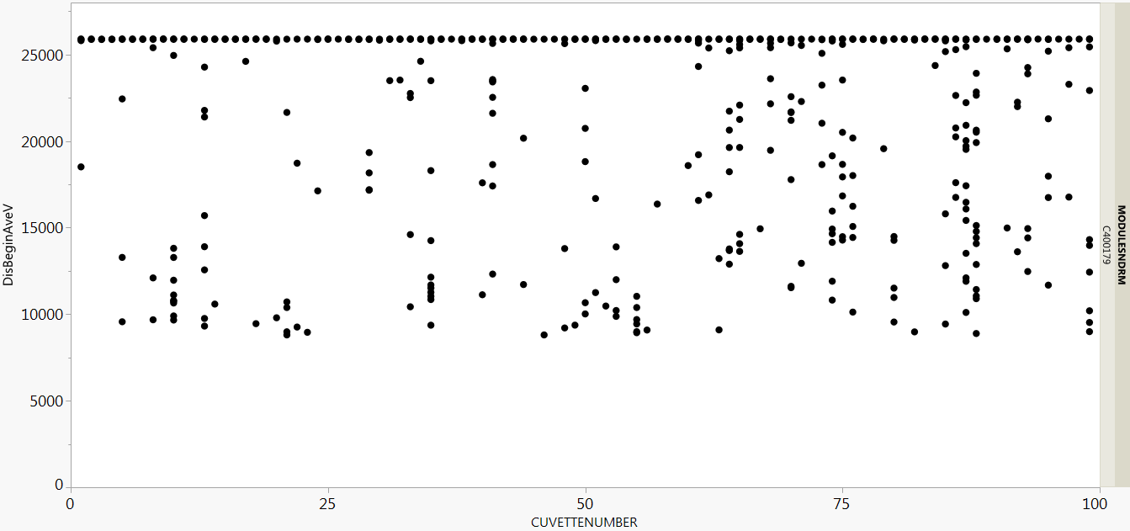

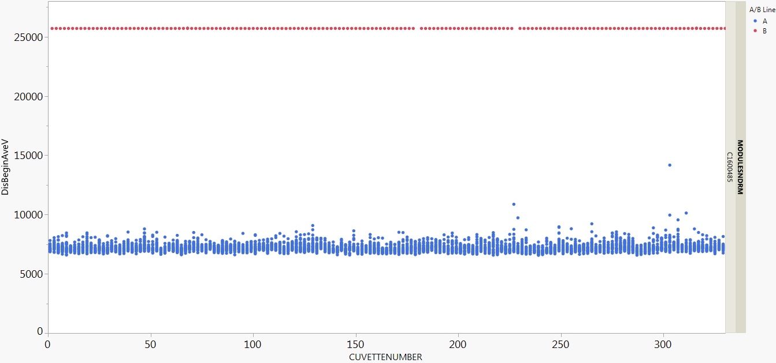

**Figure 8**. Pattern of DisBeginAveV signal for cuvette wash tower mal-function.

**Top**: Elevated DisBeginAveV occurred to all the cuvettes on c400179.

**Bottom**: Elevated DisBeginAveV occurred to all the cuvettes on B-line (red), but not on A-line (blue) on c1600485.

Typical hardware root causes for Cuvette Wash Tower mal-function include:

A. Clogged nozzles, tubing, or dryer tip; bent nozzles.

B. Pinched or disconnected tubing; leaking components.

C. Cuvette wash tower mis-alignment, etc.

For example, in case of a mal-functioning dryer tip, the deionized water left after the aspiration nozzle (#7) may not be completely removed by the dryer tip. When the cuvette wash tower height is properly aligned, the aspiration nozzle is positioned 4.5 mm above the cuvette bottom, and this gap can result in up to ~90 uL of residual water if it is not effectively removed by the dryer tip, leading to carousel-wide elevation of DisBeginAveV signal.

Caveats:

(1) It should be noted that if there are more than one individual cuvette that have sustained damage, significant amount of water can seep into these cuvettes prior to sample dispense, causing DisBeginAveV signals to elevate for multiple cuvettes. However, if the pattern of elevated LLS signal is observed for more than ~5% of the total number of cuvettes (or A- or B-line on c16000’s), cuvette wash tower mal-function should be suspected.

(2) In case when a dilution protocol is ordered for an assay where the initial sampling occurred to a damaged cuvette and the transfer of diluted sample occurred to an intact cuvette, it is the latter cuvette that is registered in the Result log. This leads to the identification of the transfer cuvette as the “suspected” cuvette during combined Result log/PM Log data pull for elevated DisBeginAveV signals. The cuvette number for the sample transfer is n+1 on c4000 and n-2 on c16000 (n is the cuvette number for the initial sampling). Practically speaking, the number of such occurrences is only about a few percent, compared to the occurrence of the elevated signals for the true damaged cuvette, and one can reasonably suspect such scenario. The current algorithm, with the threshold setting at 20% of all sampling events for the suspected cuvette, will not trigger PHN for broken/cracked cuvette falsely.

(3) Other root cause scenarios might include situations where elevated signals are present for multiple cuvettes but are all within the same cuvette segment, such as the case where a cuvette segment is not seated correctly (too low) in the reaction carousel, and wash nozzles/dryer tip cannot remove all the remaining detergent or DI water. In this scenario, the elevated signals maybe clustered on cuvettes within a particular segment.

(4) If sample probe is vertically or horizontally mis-aligned against the cuvette position, it can impact the observed pattern of these LLS signals.

# Alerts

## 4.1 Current Thresholds Set in System Software

The algorithms described in this document are new algorithms for ARCHITECT Clinical Chemistry Analyzers. Currently there are no effective Design Modes of Control for monitoring the status of the cuvettes on Architect Clinical Chemistry instruments in the period of time immediately around sample dispense. If a cuvette is broken, or if there is a problem with the cuvette wash tower (including all of its components such as nozzles, pumps, valves, tubings, dryer tip, manifold, etc.), or if the cuvette segments or wash tower are mis-aligned, the cuvette may arrive at the sampling position with an amount of pre-existing liquid that may dilute or otherwise contaminate the reaction mixture and impact its results. The existing Cuvette Integrity Check as well as Sample Dispense Pressure Monitoring modes of control are not effective in catching these failure modes.

Note that the actual extent of impact to results from the various failure events described above depends on the specific assays that are run in these cuvettes, with higher impacts on assays with low reaction volumes. The contamination may lead to either LOW of HIGH results depending on the Reaction Mode (Up or Down). Water bath constituents (e.g., Mg2+ ion) can significantly impact Magnesium assays. However, the impacted results may not always produce a Result Flag depending on the extent of bias, therefore result flagging alone may not be reliable.

## 4.2 New Thresholds

The flowchart shown below (Figure 9) describes the data processing and specifications of thresholds for the proposed new PHN alerts:



**Figure 9**. Flowchart for data processing and signal thresholds for the new Alert Codes.

The following table summarizes the proposed thresholds:

|  |  |  |  |
| --- | --- | --- | --- |
| Alert Code | Signals | Lower Threshold for AD Counts | Frequency of Occurrence |
| PHN00042 | DisReadyAveV | >15,000 for >10% of all sampling events for a suspected cuvette | >10% of ALL cuvettes are impacted for each instrument (or per line on c16000) |
| PHN00064 | DisBeginAveV | >20,000 for >20% of all sampling events for a suspected cuvette | >20% of ALL cuvettes are impacted for each instrument (per line on c16000) |
| PHN00065 | DisBeginAveV | >20,000 for >20% of all sampling events for a suspected cuvette | c4000: ≤ 4 cuvettes are impacted  c16000: ≤ 7 cuvettes are impacted per each line. |

## 4.3 Alert Details

Daily, the sample dispense LLS signals are collected for all instruments with the correct PM boards until a week worth of data is accumulated (and at least an average of 20 sampling events per cuvette). Percentages of sampling events with LLS signals above the thresholds are calculated for each suspected cuvette, and then the percentage of impacted cuvettes is calculated. The cuvette alerts are generated sequentially as follows:

(1) If the DisReadyAveV threshold is triggered, PHN00042 alter is generated, and intervention is called.

(2) If there is no PHN00042 alert: if DisBeginAveV threshold is triggered for >20% of total number of cuvettes, PHN00064 alert is generated, and intervention is called.

(3) If there is no PHN00064 alert: if DisBeginAveV threshold is triggered for less than the maximum number of cuvettes, in the above table, PHN00065 alert is generated, and intervention is called.

## 4.4 Root Cause

Known root causes for altered patterns of sample dispense LLS signals include:

**PHN00042**: faulty pre-AMP board or LLS board

**PHN00064**: broken/cracked cuvette(s)

**PHN00065**: cuvette wash tower mal-function, including clogged nozzles, tubing, or dryer tip; bent nozzles; pinched or disconnected tubing; leaking components; mis-alignment, etc.

## 4.5 Intervention Actions Needed

The following minimum intervention actions are needed depending on the specific alert codes:

**PHN00042**: replace pre-AMP board or LLS board, calibrate sample probe and inspect for vibration, inspect/align cuvette wash tower.

**PHN00064**: Inspect/replace clogged/dirty dryer tip, clogged/bent cuvette wash nozzles, and/or clogged, pinched, leaking, or disconnected tubings; align wash tower sub-assembly; calibrate sample probe.

**PHN00065**: replace individual broken/cracked cuvette(s), replace dryer tip, calibrate sample probe, and align cuvette wash tower.

Note: refer to cSystem Service & Support Manual R&R and Verification procedures outlined in the relevant Knowledge Management Articles for each notification alert PHN00042, PHN00064, and PHN00065, respectively.

# Supporting Evidence

## 5.1 Field Data Analysis

(1) Instruments with elevated DisReadyAveV

IDA data pull between December 1, 2015 to January 20, 2016 for c4000 instruments with elevated DisReadyAveV signals above 15,000 identified the following instruments (Figure 10).

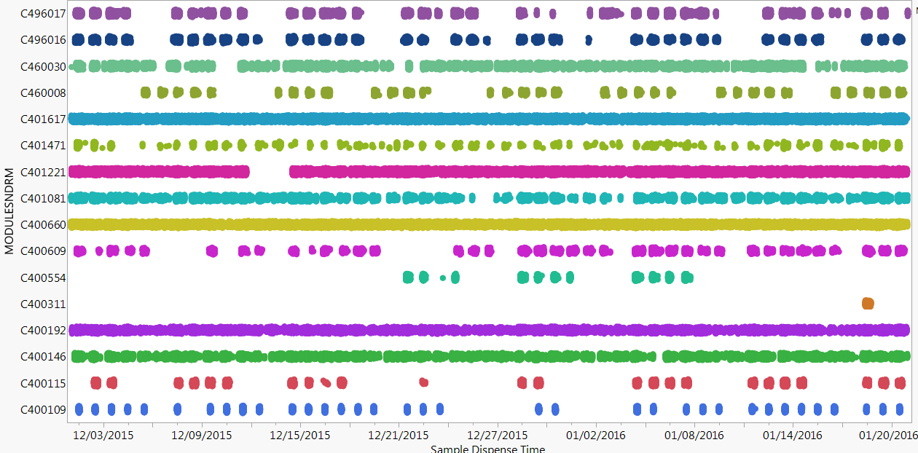

**Figure 10**. c4000 Instruments identified with elevated DisReadyAveV signals.

Most of the identified c4000 instruments were observed to exhibit persistent elevated DisReadyAveV signal, while a few (e.g., c400311) only exhibited intermittent elevated signals.

Similarly, c16000 instruments with elevated DisReadyAveV can be identified (Figure 11).

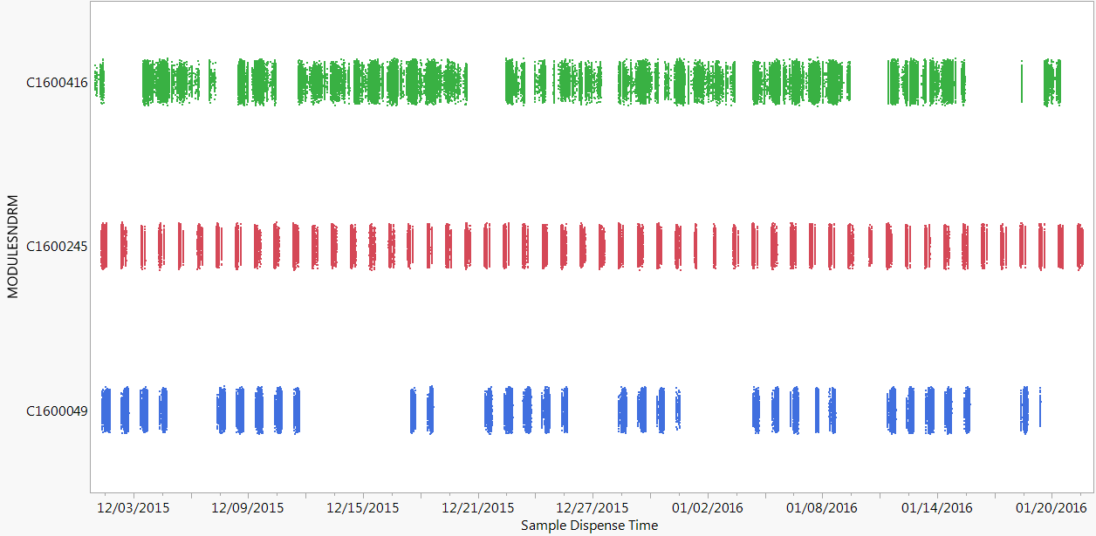

**Figure 11**. c16000 Instruments identified with elevated DisReadyAveV signals.

(2) Instruments with Elevated DisBeginAveV

IDA data pull between March 1, 2016 to March 15, 2016 for instruments with DisBeginAveV signals above 20,000 identified the following c4000 (Figure 12) and c16000 (Figure 13) instrument/cuvette combinations.

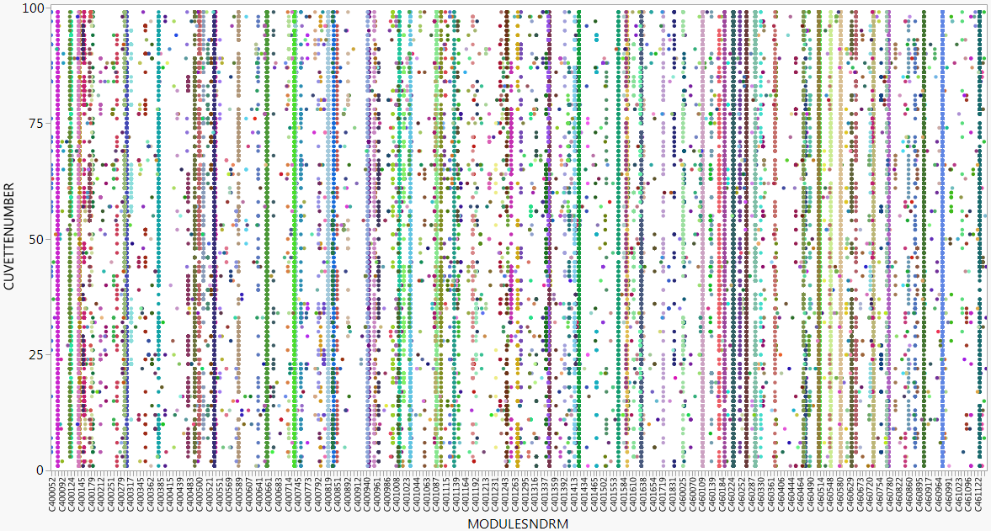

**Figure 12**. Cuvette distribution of observed elevated DisBeginAveV for c4000 instruments.

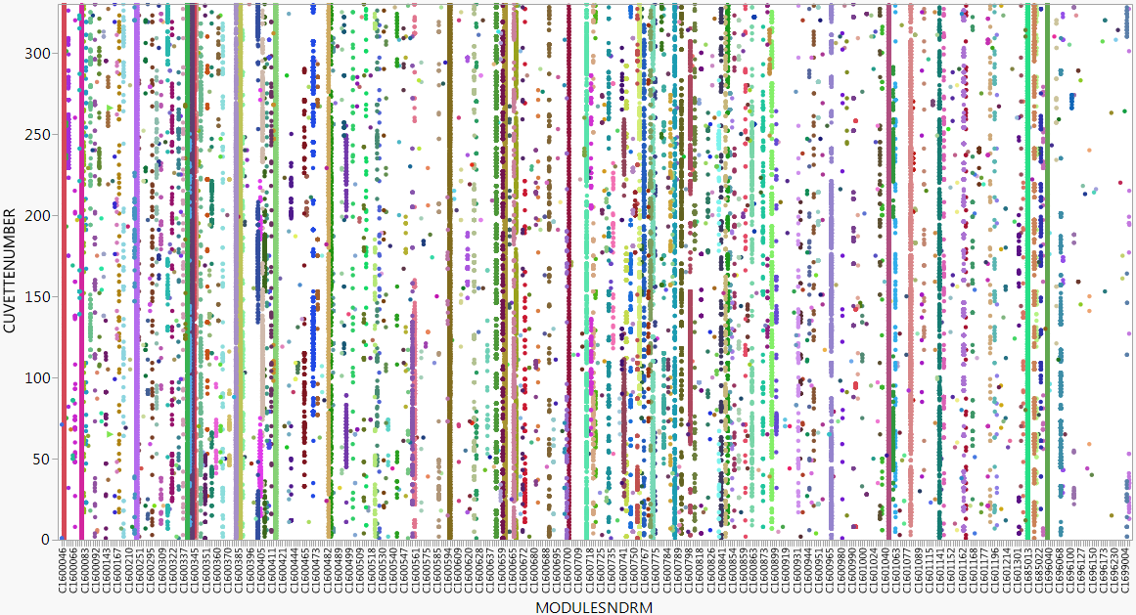

**Figure 13**. Cuvette distribution of observed elevated DisBeginAveV for c16000 instruments.

Analysis of the cuvette patterns for each instrument can identify the nature of the faulty condition between broken cuvette(s) and cuvette wash tower issues. For example:

As shown in Figure 14, cuvette #15 was identified as broken on c460779, based on the number of events for DisBeginAveV signal above 20,000.

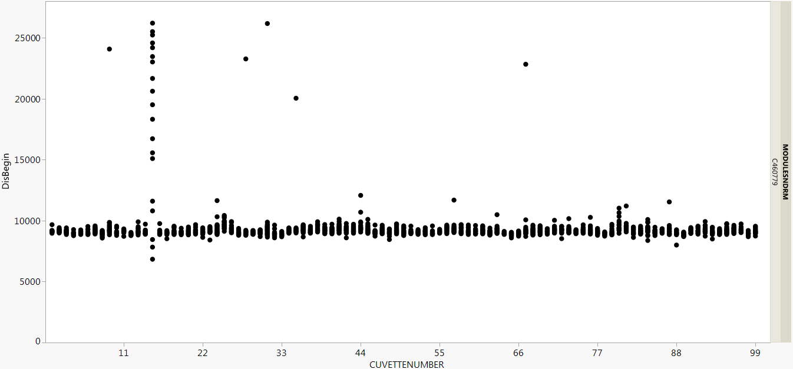

**Figure 14**. DisBeginAveV signals for all cuvettes on c460779.

As shown in Figure 15, most cuvettes on B-line (red) of c1600651 had elevated DisBeginAveV signals, signaling cuvette wash tower issue on B-line. For A-line (blue), cuvettes 13 and 57 were identified as broken, while other cuvettes are intact and there is no cuvette wash tower issue for A-line.

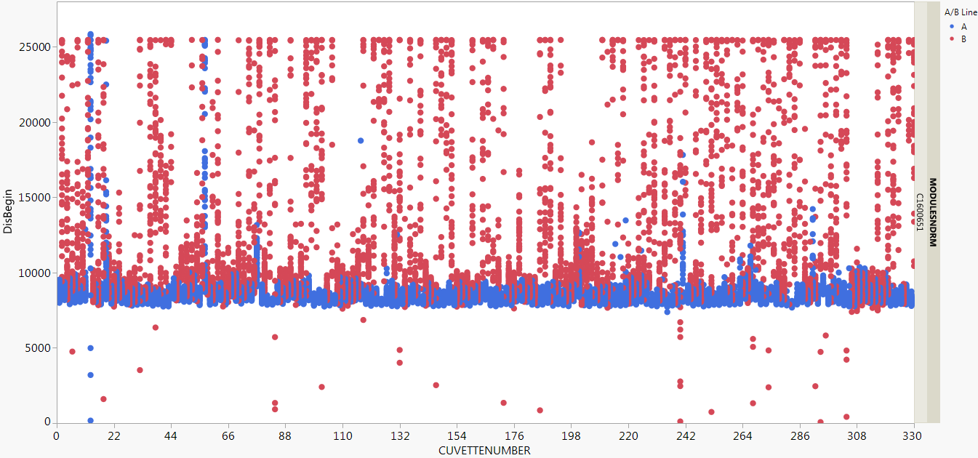

**Figure 15**. DisBeginAveV signals for all cuvettes on c1600651.

# Benefits

Currently there are no effective Design Modes of Control onboard of ARCHITECT Clinical Chemistry Analyzers that are capable of consistently detecting these cuvette-related hazard sources while processing assays. The new algorithms require no new hardware or software changes. The benefits of these alert codes include:

(1) Multiple faulty conditions related to LLS detection sub-assembly or cuvette status can be uniquely identified in real time. The signals can be readily interpreted.

(2) Intervention actions can be tailored to the specific faulty conditions based on the LLS signal pattern. Resolution is effective.

(3) Alerts lead to cost effective service visits that prevent lengthy troubleshooting, unnecessary part replacements, or multiple reactive service visits.

(4) Potential impacts to patient results can be promptly notified and be reviewed.

# Applicable Documents

## 7.1 Specification Documents

DHF-40013-000-00161 c4000/c16000 Pressure Monitoring Algorithm Document

## 7.2 System Requirements

**(1) DHF-40013-000-00576 c4000 PRD:**

c4000 PRD-1760 c4000 Residual Cuvette Water Volume:

The c4000 module shall evacuate water from a cuvette to the following residual volume specification prior to test processing:

</=1.0uL Cuvette-to-cuvette variability (within module)

</=2.0uL Single cuvette maximum volume

c4000 PRD-844 c4000 Cuvette Carryover

The c4000 module shall control cuvette carryover to less than 10.0 ppm.

**(2) DHF-40003-000-00288 c16000 PRD**

c16000 PRD-844 Cuvette Carryover

The system shall control cuvette carryover to less than 10 ppm.

## 7.3 Hazard Analysis

The table below summarizes the relevant Hazards from Risk Management Reports (RMR) DHF-40013-000-00520 (c4000) and DHF-40003-000-0199 (c16000) that the new algorithms can mitigate:

|  |  |  |  |  |  |
| --- | --- | --- | --- | --- | --- |
| Object ID  Number | | | Hazard Source | Cause | Severity / Probability / Risk Level |
|  |  |  |
| 1506 | | | Incorrect or Delayed Patient Result:  Contamination of the clinical chemistry module cuvette causes incorrect patient result | Contamination from cuvette washer. | Major / Improbable / Low |
| 3249 | | | Incorrect or Delayed Patient Result:  Contamination of the clinical chemistry module cuvette causes incorrect patient result | Contamination from water bath. | Major / Rare / Medium |
| 1495 | | | Incorrect or Delayed Patient Result:  Contamination of the clinical chemistry module cuvette causes incorrect patient result | Cuvettes not washed properly. | Major / Rare / Medium |
| 1452 | | | Incorrect or Delayed Patient Result:  Cracked or leaking cc cuvettes | Damaged during shipping, packing and storage. | Major / Improbable / Low |
| 1450 | | | Incorrect or Delayed Patient Result:  Cracked or leaking cc cuvettes | Operator handling/ mishandling. | Major / Improbable / Low |
| 1448 | | | Incorrect or Delayed Patient Result:  Cracked or leaking cc cuvettes | Cuvette washer or Probe misalignment. | Major / Improbable / Low |
| 1447 | | | Incorrect or Delayed Patient Result:  Cracked or leaking cc cuvettes | Instrument imparts static charge on cuvettes. | Major / Improbable / Low |
| 989 | | | Incorrect or Delayed Patient Result: Insufficient Cuvette Washing -CC | Washer misalignment. | Major / Improbable / Low |
| 986 | | | Incorrect or Delayed Patient Result: Insufficient Cuvette Washing -CC | Obstruction in wash / dry head. | Major / Improbable / Low |
| 984 | | | Incorrect or Delayed Patient Result: Insufficient Cuvette Washing -CC | Insufficient wash solution volume. | Major / Improbable / Low |
| 977 | | | Incorrect or Delayed Patient Result: Insufficient Cuvette Washing -CC | Valve / tubing / syringe / connector failure resulting in dripping / bubbles in tubing. | Major / Improbable / Low |
| 974 | | | Incorrect or Delayed Patient Result: Insufficient Cuvette Washing -CC | Valve or syringe failure resulting in insufficient wash. | Major / Rare / Medium |